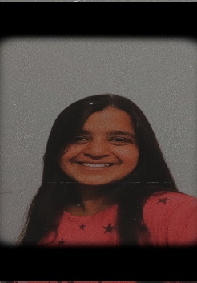
Resume
- Name: Pritha Rai
- E-mail: pritharai873@gmail.com
- Contact No.: 9041307588

- Objective: A hardworking and motivated student with excellent leadership and communication skills with a diverse background of extra-curricular activities and active participation in sports and literary events. Possessing a keen interest in programming and technical activities. Seeking an entry-level position to begin my career in a high-level professional environment.
- Qualification:
Year | Education | School/University | Percentage
2022-2026 | B. Tech (CSE) | PCTE | Pursuing
2021-2022 | Higher Secondary | BCM Sr. Sec. School | 65%
2019-2020 | Matriculation | St. Thomas Sr. Sec. School | 89.1%

- Personal Skills:
- Sportsmanship
- Communication
- Leadership

- Technical Skills:
- Microsoft Office
- AutoCAD
- HTML
- CSS
- C
- Python
- SQL

- Achievements:
- Won 2nd prize in Business Plan
- Won 1st prize in JAM (Just A Minute)
- Ranked 1st in School level NSO
- Ranked 2nd in Interschool Poetry competition
- Won 1st position in Football
- Got 2nd position in skipping & volleyball
- Got 3rd position in basketball

- Academic Projects:
- Prefect of the school house for two consecutive years
- Taking part in literary events like Debate and poetry composition
- Leading Swachh Bharat Abhiyaan Campaign throughout the city with 20 companions.
- Creating my own portfolio website and poetry website using HTML, CSS, JavaScript.
- Creating minor projects using C language like Restaurant billing system.

- Language Proficiency
Proficient in:
- English
- Hindi
- Punjabi
- Bengali
Learning:
- French
- Korean
- Japanese

Personal Details
- Father’s Name: Mr. Samir Ray
- Mother’s Name: Ms. Renu Rai
- Address: #201/G.K. Vihar, Manekwal Road, Near Jain Mandir, Ludhiana, Punjab
- Contact no: 9041307588, 8968688938

Confirmation: Above information is correct & above of knowledge.

